Process Scheduling

The process of choosing the process Ready Queue for dispatch in CPU for Run/exec is done by process scheduling. This selection is done by process scheduling algorithm – CPU scheduling

Module which gives the process access to CPu is dispatcher

Two types of Scheduling Algorithm

1. Non-Pre-emptive scheduling - Once CPU has been allocated to a process, the process keeps the CPU until it releases CPU either by terminating or by switching to wait state
   1. No time quantum taken care in Non – Pre-emptive
   2. More Process Starvation bcoz of no time sharing
   3. Less Cpu utilization
   4. Overhead is less
2. Pre-emptive scheduling - 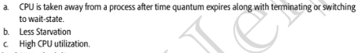
   1. Overhead is high as no of process changes is high

Goals of CPU Scheduling Algorithms:

1. Maximum CPU utilisation
2. Minimum Turnaround Time(Tat) – Time taken fromfirst time process enters ready state till it terminates.
3. Minimum wait time – Processs spendswaiting for CPU
4. Min. Response time
5. Maximum through put - no of processes completed per unit time
6. 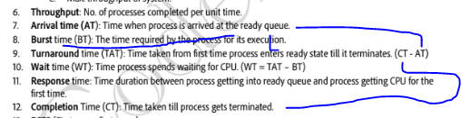

Scheduling Algorithm – FCFS

1. It will select prcess which comes first and then following
2. FCFS – First come first Serve
3. 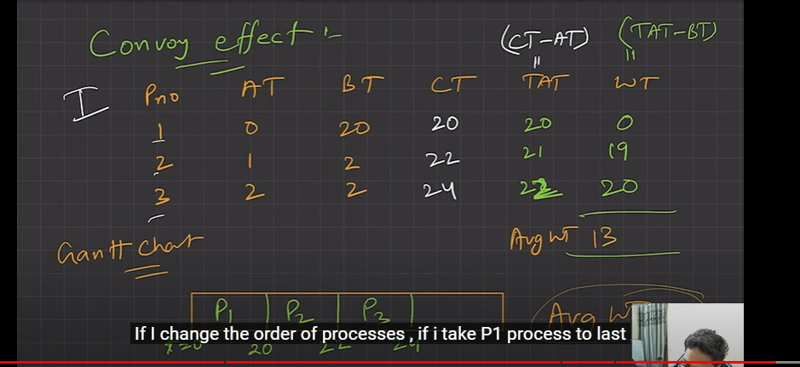
4. Here we have avg wait time of 13
5. But if we put Pno 1 in last [p3, p2, p1]. So avg becomes 1
6. 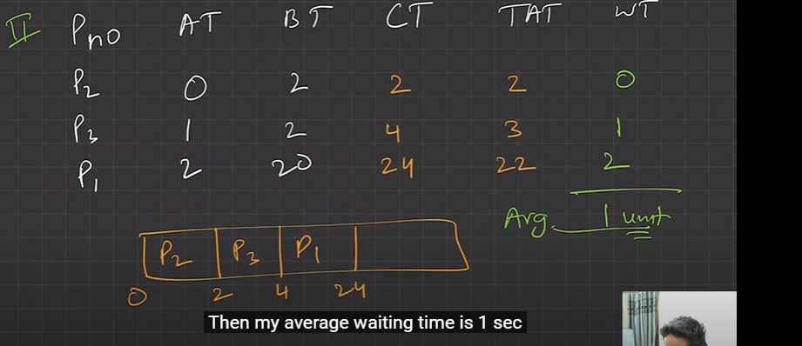
7. \*\*\*
8. 